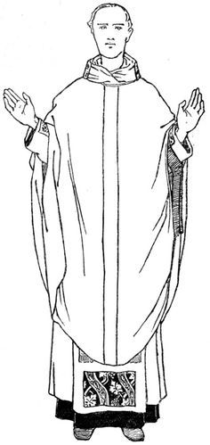

Write or draw something you heard in the sermon.

Who celebrated Mass?

What color was the Priest’s vestment? (Color the priest’s vestment)

**Sermon Notes for Religious Education Students**



As you watch mass today on TV or Facebook with your family, use this sheet to help you pay attention and learn. We want you to worship with us by singing to God and listening to the message for today.



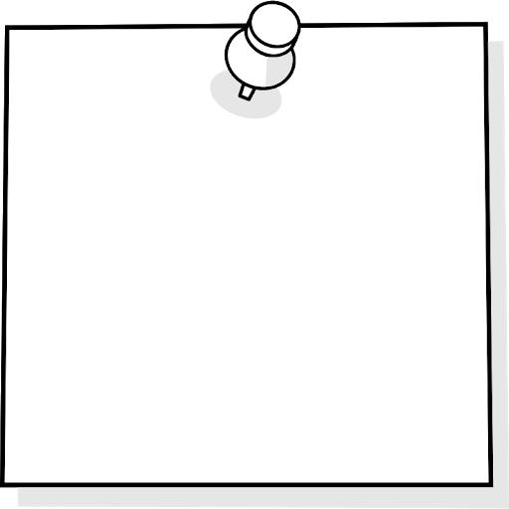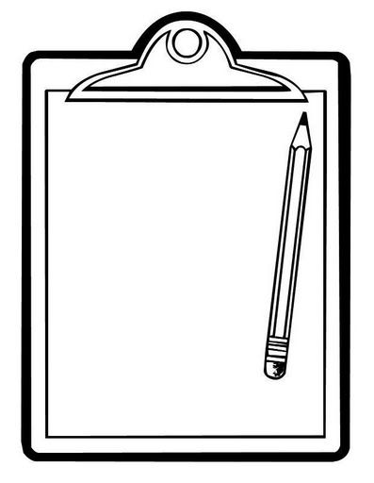

What is the main passage we are reading today?

Book:

Chapter:

Verse:

The most important thing you learned was:

How does today’s message apply to your life?

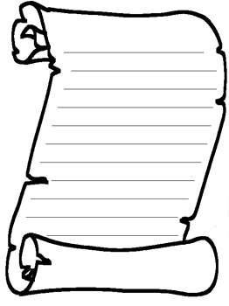

What are we learning about God from this passage?

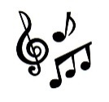

Favorite Song today was:

______________________________________

___________________

___________________